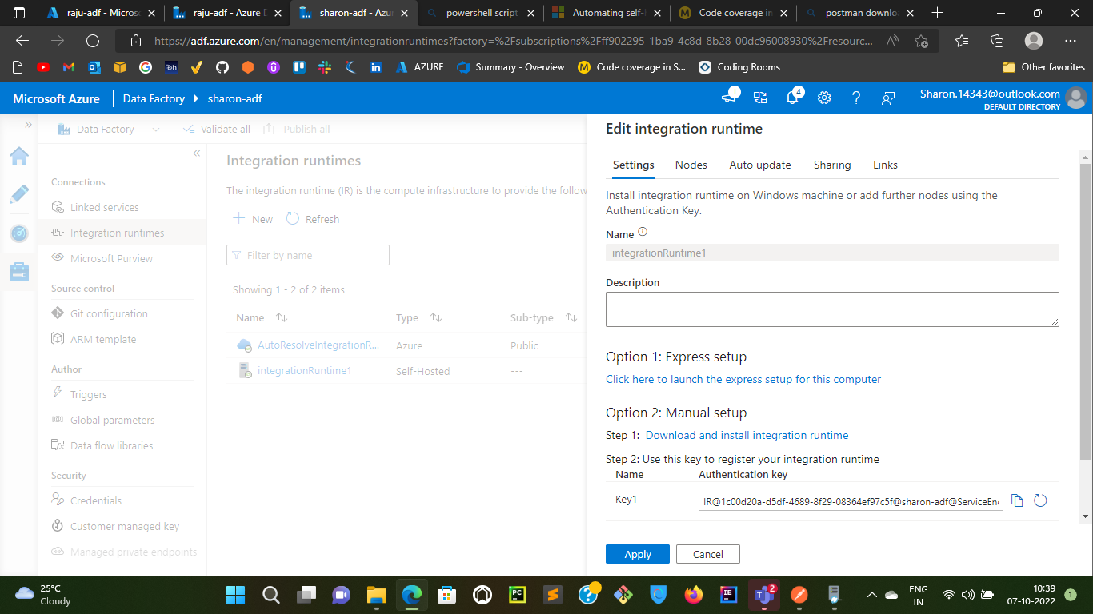

**Nodes:** The maximum nodes you can add is 4 as of now.

1. You can add the node by sharing the authentication key to the user who wants to add the node to the existing runtime.

**Auto-Update:** You can set if you want to update the runtime by yourself or you can set azure to take care of the updates.

1. You can schedule the update to be made at specific time interval

**Sharing:** You can share or link the existing IR to other data factories as well

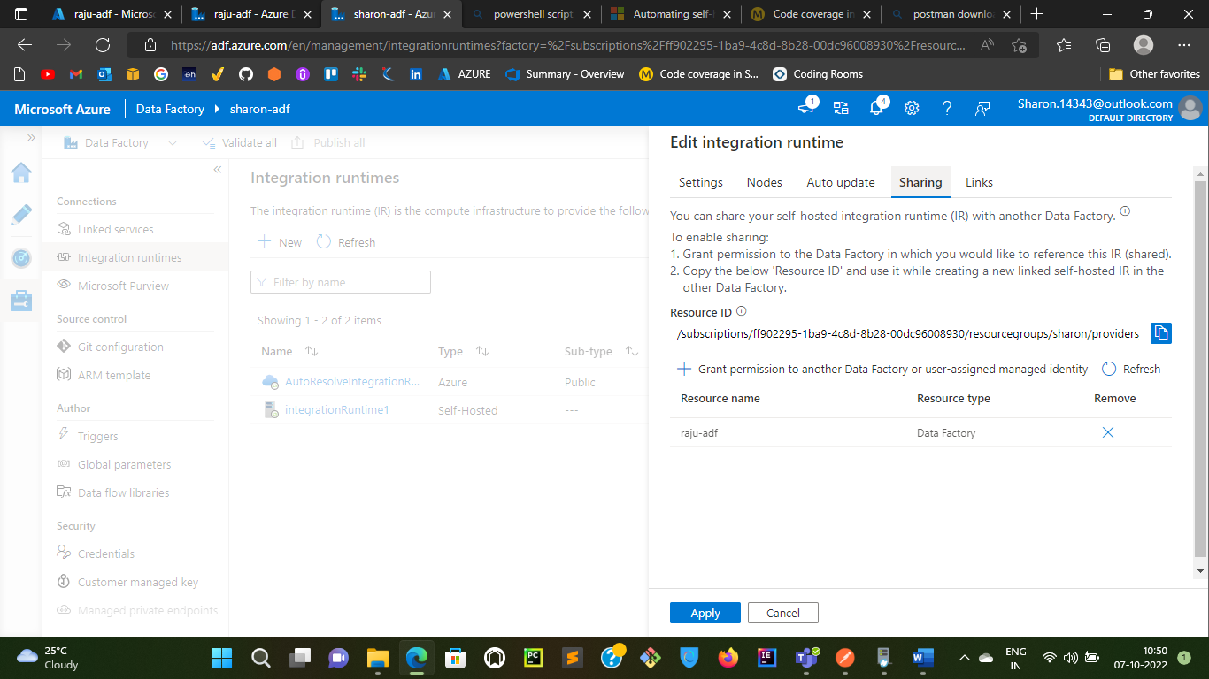

1. Create another data factory in the azure Portal
2. Copy resource id that you can see in the above diagram
3. Now you can link the existing IR with other ADF by following below images

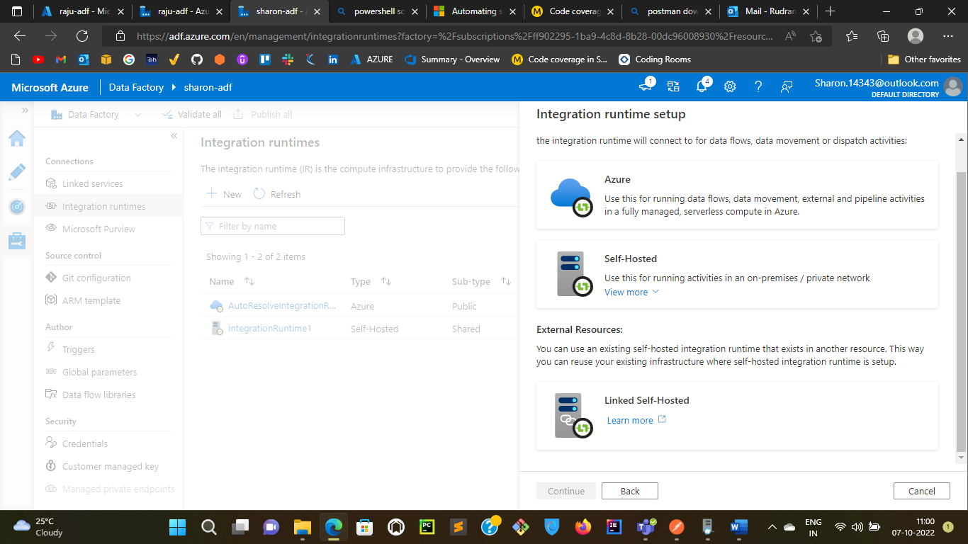

1. Click on Linked Self-Hosted
2. Copy the above resource ID into the below resource ID box and click on create. By this way you can share existing IR with the other ADF’s

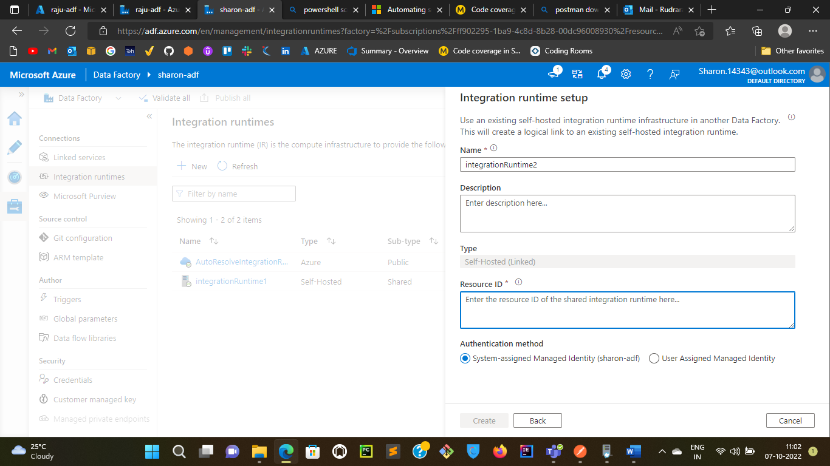

1. Once you click on create the other ADF will be displayed in the sharing section as shown below:

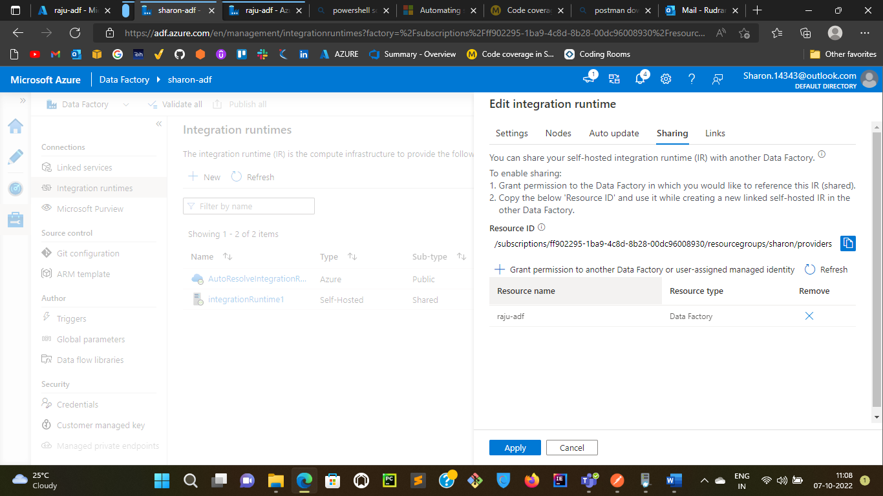

**Links:** The list of linked integration runtimes that are created to share with this integration runtime.

The list can be shown as below

